
Changing Sun

The Sun changes through the day.

a. How does the Sun appear to change through a day?
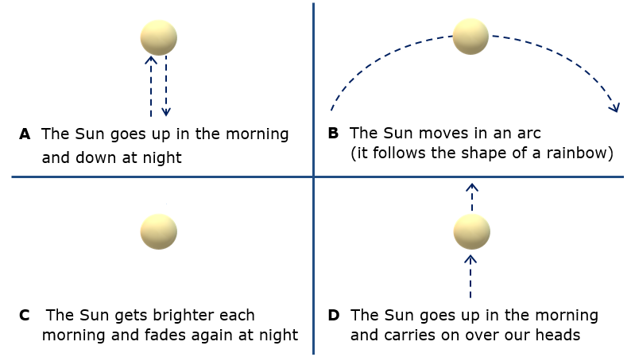

b. What is the best reason for your last answer?
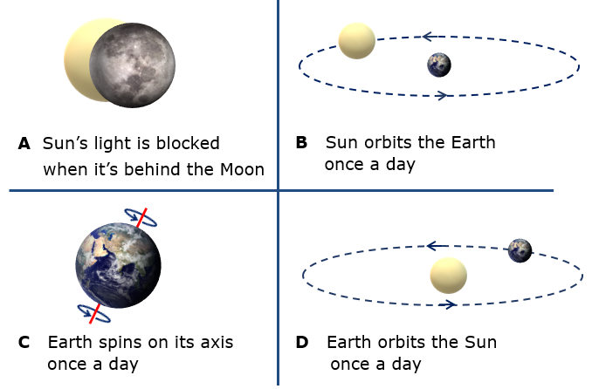
Physics > Big idea PES: Earth in space > Topic PES2: Earth and Sun > Key concept PES2.1: Days and seasons
Diagnostic question
Changing Sun

Overview
Learning focus: | The temperature is higher in the summer because the tilt of the spinning Earth increases the length of a day and increases the heating effect of the Sun’s radiation.
Observable learning outcome: | Describe the apparent movement of the Sun during the day.
Question type: | Two-tier multiple choice
Key words: | Spin, orbit

P | PRIOR UNDERSTANDING  This diagnostic question probes understanding of ideas that are usually taught at age 5-11, to aid transition from earlier stages of learning.

What does the research say?
Students often learn about the cause of day and night in primary school at ages 9-11 (Department for Education, 2013) and it can be tempting to keep this work simple and descriptive when in fact it is conceptually demanding (Osborne, 2011). The scientific explanations for simple observations such as the Sun moving across the sky each day are not obvious and sometimes counter intuitive. The Sun’s ‘movement’ across the sky happens not because the Sun is moving, which is the most obvious explanation, but because the Earth is spinning on its axis.
At age 11-14 most students understand the Earth to be a sphere and describe the cause of day and night in terms of the movement of astronomical bodies (Driver et al., 1994; Baxter, 1989; Bakas and Mikropoulos, 2003; Brewer and Vosniadou, 1994; Sharp, 1996).
In order to build and consolidate students’ understanding of day and night, the use of physical models has been shown to be an effective strategy (Bakas and Mikropoulos, 2003; Lelliott and Rollnick, 2009). Models can be used to explain day and night and why the tilt of the Earth alters the length of the day at different times of the year.
Ways to use this question
Students should complete the questions individually. This could be a pencil and paper exercise, or you could use an electronic ‘voting system’ or mini white boards and the PowerPoint presentation. The follow on question will give you insights into how they are thinking and highlight specific misconceptions that some may hold.
If there is a range of answers, you may choose to respond through structured class discussion. Ask one student to explain why they gave the answer they did; ask another student to explain why they agree with them; ask another to explain why they disagree, and so on. This sort of discussion gives students the opportunity to explore their thinking and for you to really understand their learning needs.
Differentiation
You may choose to read the questions to the class, so that everyone can focus on the science. In some situations it may be more appropriate for a teaching assistant to read for one or two students.
Expected answers
a. B: The Sun moves in an arc. (NB the arrow on the arc needs reversing if you live in the southern hemisphere. Answer D is sometimes correct if you live close to the Equator.)
b. C: Earth spins on its axis once a day.
How to respond - what next?
A few students may hold the naïve understanding that the Sun brightens and dims each day, or is hidden by clouds or the Moon at night. Most will understand that the Sun appears to move in the sky and that it is closer to the ground early morning and late evening. It is likely that a significant number will not be able to describe the Sun’s actual movement. It is common for students to think (wrongly) that the Sun is always directly overhead at midday.
In part b answer D is a common response and partially fits with the correct model of the Earth going around the Sun. Answer B shows a more egocentric view that fits with students’ observations that the Sun appears to move around the Earth, and indeed makes perfect sense from the point of view of the observer. Answer A is related to the false idea that the moon only appears in the sky during the night-time.
All of these misunderstandings show a lot of persistence, perhaps because the scientific view is a more complex and less obvious explanation.
If students have misunderstandings about how the Sun appears to change through the day, it can help to model what happens. A simple strategy is to ask each student to stand up and to turn slowly on the spot in an anti-clockwise direction (clockwise if you are in the southern hemisphere). Whilst turning they should point at a picture of the Sun at the front of the room. Through their spin they will trace the movement of the Sun to show it moves across their field of view.
To show how the Sun appears high in the sky at midday, students should be asked to point at the picture whilst leaning forwards. (Placing a plastic figure on a globe shows how most places on the Earth are tilted towards the Sun at midday.) Standing up straight, whilst keeping their arm at the same angle at which they were pointing, will show students how high the Sun appears in the sky. If students then turn sideways whilst leaning forwards and point at the same picture of the Sun, they will find when they stand up straight they will be pointing low down towards the horizon.
For any students who need reminding of the causes of day and night, a globe can be used in a darkened room, illuminated on one side with a strong light such as an overhead projector. This will give a clear distinction between light and shade on the globe. A small piece of Blu-Tack placed on your location will show how day and night occur as the globe is spun on its axis (once per day). The correct direction to spin is anti-clockwise whilst looking down at the North Pole.
The following BEST ‘response activity’ could be used in follow-up to this diagnostic question, to help students understand and explain the scientific explanation for these observations:
- Response activity: Long days of summer
Acknowledgments
Developed by Peter Fairhurst (UYSEG).
Images: Peter Fairhurst (UYSEG).
References
Bakas, C. and Mikropoulos, T. (2003). Design of virtual environments for the comprehension of planetary phenomena based on students' ideas. International Journal of Science Education, 25:8, 949-967.
Baxter, J. (1989). Children's understanding of familiar astronomical events. International Journal of Science Education, 11 (Special Issue), 502-13.
Brewer, W. and Vosniadou, S. (1994). Mental Models of the Daylight Cycle. Cognitive Science, 18, 123-183.
Department for Education (2013). Science programmes of study: key stages 1 and 2 - National curriculum in England (DFE-00182-2013), London, UK.
Driver, R., et al. (1994). Making Sense of Secondary Science: Research into Children's Ideas, London, UK: Routledge.
Lelliott, A. and Rollnick, M. (2009). Big Ideas: A review of astronomy education research 1974-2008. International Journal of Science Education, 32:13, 1771-1799.
Osborne, J. (2011). Earth in Space. In Sang, D. (ed.) Teaching Secondary Physics. London: Hodder Education.
Sharp, J. G. (1996). Children's astronomical beliefs: a preliminary study of Year 6 children in south-west England. International Journal of Science Education, 18(6), 685-712.

